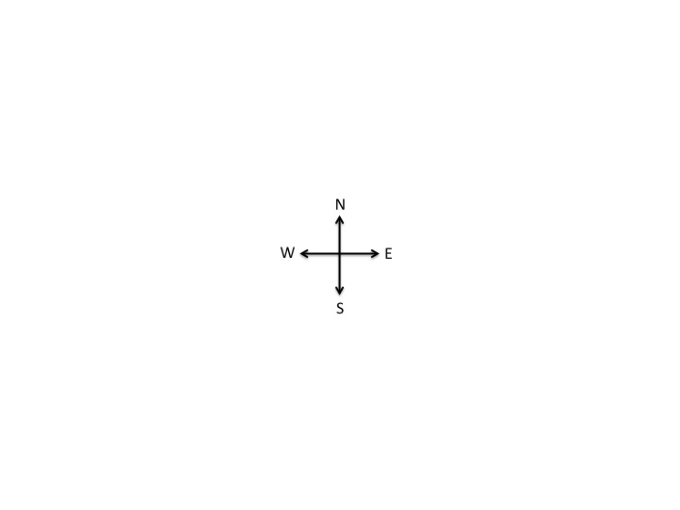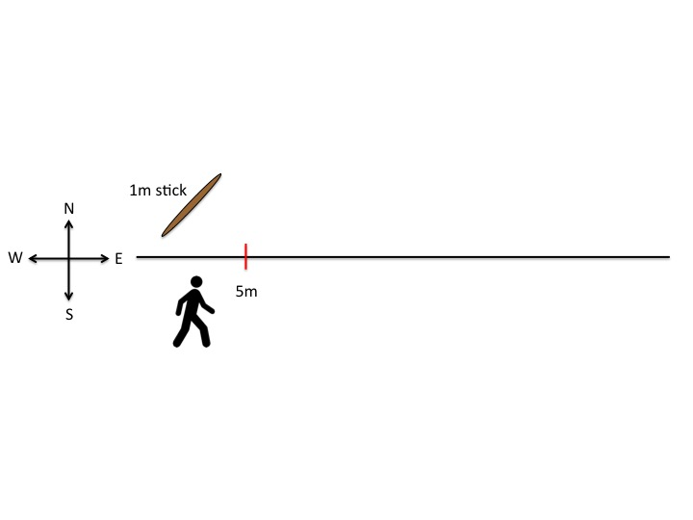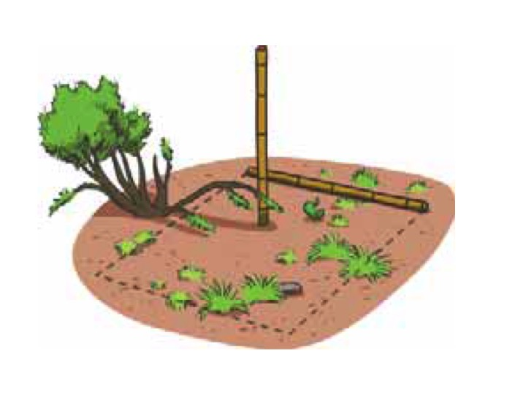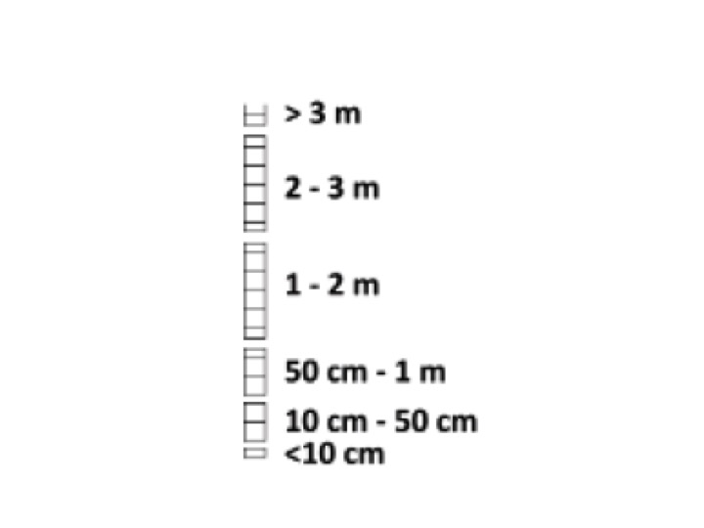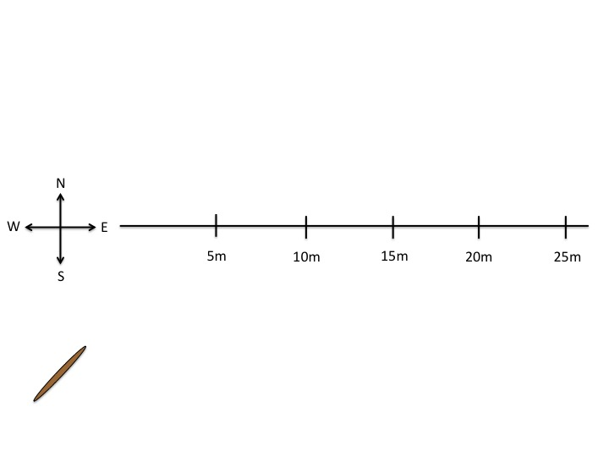

CUT TO: A close up of the area appears. Another appears and helps create an outline of the 1x1m box. The stick is placed vertically to observe tallest plant in box. One example plant is circled in red

FADE IN: A person fades in holding a stick. He walks until he reaches 5m. He puts the stick down in front of him. And bends down to make an observation

OPEN TO: The cross appears on the screen. The cross moves to the left and a line to the east extends out.

CUT TO: A close up of the data sheet appears. A hand checks off the height of the plant.

CUT TO: The person walks the 25 m length. The animation shows the person dropping the stick at each mark, but does not show the whole detail again.